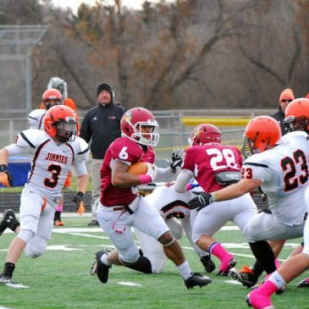
James Gaynor Jr.
#6
Valley City State University
WR/RB/KR/PR/LS
5’7” 178 lbs.
Career: 65 Recs, 687 Rec yards, 107 carries, 604 rushing yards, 46 Kick returns for 1077 yards, 15 Punt returns for 146 yards, 29 ST tackles, 4 Forced Fumbles, 1 Fumble Recovered, 1 Blocked Kick, 32 games started at Snapper, 8 Total TDs

Strengths | Weaknesses
Versatility: Has WR hands, but has the ability to make quick moves like a RB. He is a mismatch on any linebacker in the slot and can go the distance in spot. His shiftiness helps him be a threat in the return game as a Kick and Punt returner as well. | Height: at 5’7” it will be tough for James to have any advantage going against CBs as his catching radius is smaller compared to other WRs. Teams tend to stay away from smaller players, so this may hinder his chance to make a team.
Knack for finding the hole in Zone Coverage: Has the ability to consistently find the soft spot in the zone and exploit the defense. Knows the linebackers movements and goes to the spot where the defender cannot make a play on the ball and instead can be caught by him. | Weight: gaining another 10-15 pounds could help Gaynor withstand the constant wear and tear of the season. 178 lbs. works in college but at the next level a thick frame matters.
Special teams Ace: Can returns Kicks and Punts. Can also short snap to kicker and long snap to the punter. As a gunner will go down the field and make the tackle. Led the team in ST tackles in 2009, 2012, and 2013 | Competition: There will be a big adjustment going from the NSAA to the NFL where everyone is bigger faster and stronger. Adjusting to the talent may be the biggest challenge for Gaynor.
Team Player: James is the ultimate team player, shown by his unselfish behavior and willingness to do whatever will help put the team in the best position to win. He sacrificed his own stats for the better of the team. | Lack of domination statistically: Statistically you did not dominate your competition, but part of this is because of your unselfish character willing to play whatever position to benefit the team.
Quick Feet & Burst: he is quick of the ball and moves very well in space with good cuts and quickness. He doesn’t need much time to get up to top speed and leave defenders behind him. Sudden quickness and burst.
Summary: James is by far one of the most versatile players I have ever seen. To be able to play all offensive playmaking position as well as long snapper is the ultimate test of your mantle as a player. You play with a tough chip on your shoulder that makes you play much bigger than your size at 5’7”. You can run the ball, catch the ball in space, or catch the ball over the middle. Your versatility extends to returning kicks and punts, something you did really well while at Valley City. You are not afraid to take the hit or dish one out from the gunner position on special teams.
Despite your big heart, measurable due count in the eyes of teams, and a player 5’7” sometimes get removed completely off of teams list of potential prospects to add on to the roster. They view the player as being too small to effectively compete with competition that is stronger and faster at the next level. The competition that he faced in NSAA and the competition that he will face in the pro level will be a major adjustment. Right now James is faster than a lot of people in the NSAA, but on the pro level, everyone will be fast, so his major advantage quickly becomes neutralized to an extent.
Even with your versatility, your bread and butter may best be used on special teams, as a Kick returner, punt returner, and gunner. Your ability to find the hole in the defense’s zone stretches out to finding the opening in opposing team’s kickoff teams. Your versatility will make you a gadget player at the next level with special packages ala Darren Sproles, Jerrel Jernigan, or Trindon Holliday. Your unselfish behavior and willingness to help the team playing whatever position, is your most dangerous weapon and will be a welcome addition to any team looking for a core value player. With the league more matchup based, the more you can do the greater chance you have at making a team.
Comparison: Danny Woodhead

