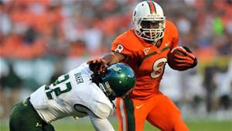
Duke Johnson
RB
Miami
5’9” 207 lbs.

Strengths | Weaknesses | Combine results
Speed/ burst | Small frame | 40 yard dash- 4.54
Good vision | Injury history | Vertical- 33.5
Gamebreaking potential | fumbles | Broad- 121 inches
Return ability | Pass protection
physical | Strings out run
Complete RB | Occasionally Runs to darkness

Games watched: Nebraska 2014, Virginia Tech 2014, Florida State 2014, Virginia 2014
Summary: Duke Johnson is a gamebreaker with the potential to take a short gain the distance for 6. Despite his 5’9” frame, he plays with the physicality of a RB that’s 6’0”. He is not afraid of going in between the tackles to gain the tough yards however he is at his best when is out on the edge displaying his dangerous breakaway speed. He will not only remain a threat on the field during 3rd down with his catching ability, he also provides value in the return game (2 kickoff returns for a TD as a freshman). The negatives on Johnson start off with his small frame. This smallish frame creates the question of can he stay healthy and/or handle a full workload. In the past he has suffered injuries including a broken ankle. When running in between the tackles, Duke will occasionally run into the line instead of finding the open hole leading him to string out runs and get caught behind the line of scrimmage. Although he also struggles with ball security and pass protection, both of these can be coached upped with better technique. I believe Duke Johnson has the potential to be an explosive weapon in an NFL offense and a true game changer.
Scheme Fit: Zone
Comparison: David Wilson
Projected Round: 2nd round
Best Fits: Detroit Lions, Oakland Raiders, New York Jets, Miami Dolphins

