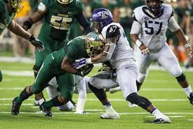
Paul Dawson
ILB/ OLB
TCU
6’0” 235 lbs.

Strengths | Weaknesses | Combine results
Read and react ability | Character | 40yd dash- 4.75
Physical, attacking mode | Size | Bench- 21
Instincts | Stack and shed blocks | Vertical- 30 inches
Plays well in coverage | Not overly athletic | 3 cone- 6.76
Always around the ball | May only be a 4-3 WLB | Broad- 112 inches
Motor | Grabs in coverage | 20 yd shuttle- 4.49

Games watched: Oklahoma 2014, West Virginia 2014, Texas 2014, and Minnesota 2014
Summary: Paul Dawson is one of the top LB prospect in the 2015 draft class. His instincts and reaction ability lead him to constantly be around the ball wrecking havoc. He is a physical downhill attacking LB that plays bigger than his 6’ 235 lb frame. He is comfortable in zone coverage albeit tends to get grabbing when covering a player in man coverage. While he is a physical player, he tends to struggle against stack and shedding offensive lineman which may limit his potential in the NFL to a pure 4-3 WILL linebacker. Dawson’s biggest issue is his character. He was a disruptive locker room presence and has come across as arrogant throughout the draft process.
Scheme Fit: 4-3 defense
Comparison: Vontaze Burfict
Projected Round: 2nd round
Best Fits: NY Giants, Atlanta Falcons, Dallas Cowboys, Miami Dolphins, Oakland Raiders

