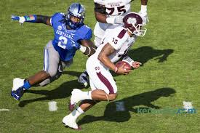
Alvin Dupree
DE/ OLB
Kentucky
6’4” 269 lbs

Strengths | Weaknesses | Combine results
Height/ weight/ speed | Raw- untapped ability | 40 yd- 4.56 (TP)
Freak Athleticism, burst | Slow to recognize play | Vertical- 42 (TP)
Plays run and pass | Needs to develop pass rush | Broad- 138 inches (TP)
Shows ability to rush the QB | Better hand usage | 20 yd shuttle- 4.47
Versatility 4-3 DE or 3-4 OLB |  | 3-cone- 7.49
Strong at the POA

Games watched: S. Carolina 2014, Florida 2014, Missouri 2014, Louisville 2014
Summary: Alvin Dupree is not only one of the best players in this draft, but he is one of my favorite players in this draft class. He has the potential to be the best edge rusher out of this crop due to his pure freakish athleticism. There are other pass rushers that get more notoriety, but Dupree doesn’t share the physical or upside limitations the others due. He plays both the run and the pass and does a pretty good job of being stout at the POA. His versatility to play the 4-3 DE or a 3-4 OLB make him one of the few two-way edge rushers in the 2015 draft class. His weaknesses are wrapped around his inexperience and the fact that he will need time to recognize plays, develop better hand use and develop pass rush maneuvers.
Scheme Fit: 4-3 DE or 3-4 OLB
Comparison: Jason Pierre-Paul
Projected Round: 1st round
Best Fits: Atlanta Falcons, NY Giants, Houston Texans, New Orleans Saints, Arizona Cardinals

