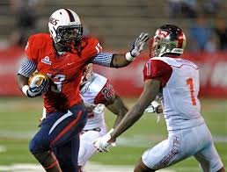
Wes Saxton
TE
South Alabama
6’3” 248”

Strengths | Weaknesses | Combine results
Mismatch in the slot | Only flex TE | 40 yd dash- 4.65 (TP)
Good hands | Not a blocker | 3 cone- 7.29
Gets in and out of breaks quickly | Still needs to learn the position | 20 yd shuttle- 4.49
Red zone threat | Not physical as a blocker | Broad jump- 119 inches (TP)
Lined up at Slot, FB, & TE | Rounds out routes | Vertical jump- 36 inches (TP)
 |  | Bench- 19

Games watched: Mississippi State 2014, Kent State 2013, Western Kentucky 2013, and Tennessee 2013
Summary: Wes Saxton is coming into the NFL at the perfect time when offensives are using specific players to lineup mismatches across the field to exploit a defense. This is what Saxton is; he is too fast for linebackers but is too big for safeties as well. He will be a natural red zone threat with his good hands and his ability to get in and out of his breaks. He displays a good ability to attack the ball (see Kent State 2013) and exploit slow linebackers (see W. Kentucky 2013). His biggest weakness is his lack of being a traditional in-line TE, thus what teams drafts him is key because they must understand he is a “Joker” TE and nothing else. He will also need time to develop and get acclimated to the pro game. Don’t be surprised if he goes higher than the 5th round.
Scheme Fit: Multiple TE offense
Comparison: Richard Rodgers
Projected Round: 5th round
Best Fits: New England Patriots, Denver Broncos, Cincinnati Bengals,

